1.Advanced SQL Concepts
Exercises for Online Retail Store
Exercise 1: Ranking and Window Functions
Goal: Use ROW_NUMBER(), RANK(), DENSE_RANK(), OVER(), and PARTITION BY.
Scenario:
Find the top 3 most expensive products in each category using different ranking functions.
Steps:
1. Use ROW_NUMBER() to assign a unique rank within each category.
2. Use RANK() and DENSE_RANK() to compare how ties are handled.
3. Use PARTITION BY Category and ORDER BY Price DESC.

Result: 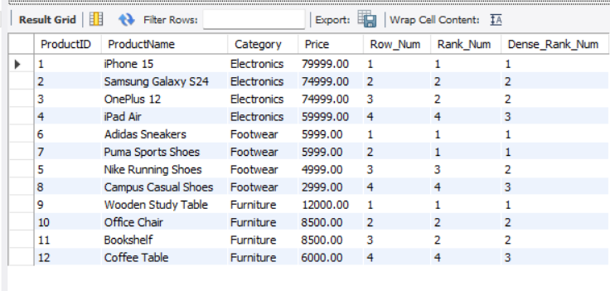

https://github.com/monu9523/Advanced-SQL/blob/main/1_AdvanceConcepts.sql

2. SQL -INDEX
-- Exercise 1: Creating a Non-Clustered Index
-- Goal: Create a non-clustered index on the ProductName column in the Products table and compare query execution time before and after index creation.

-- Step 1: Query to fetch product details before index creation
SELECT * FROM Products WHERE ProductName = 'Laptop';

-- Step 2: Create a non-clustered index on ProductName
CREATE INDEX IX_Products_ProductName
ON Products (ProductName);
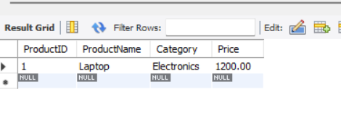

-- Step 3: Query to fetch product details after index creation
SELECT * FROM Products WHERE ProductName = 'Laptop';

-- Exercise 2: Creating a Clustered Index
-- Goal: Create a clustered index on the OrderDate column in the Orders table and compare query execution time before and after index creation.

-- Step 1: Query to fetch orders before index creation
SELECT * FROM Orders WHERE OrderDate = '2023-01-15';

-- Step 2: Create a clustered index on OrderDate
CREATE INDEX IX_Orders_OrderDate
ON Orders(OrderDate);
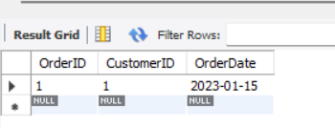

-- Step 3: Query to fetch orders after index creation
SELECT * FROM Orders WHERE OrderDate = '2023-01-15';

-- Exercise 3: Creating a Composite Index
-- Goal: Create a composite index on the CustomerID and OrderDate columns in the Orders table and compare query execution time before and after index creation.

-- Step 1: Query to fetch orders before index creation
SELECT * FROM Orders WHERE CustomerID = 1 AND OrderDate = '2023-01-15';

-- Step 2: Create a composite index on CustomerID and OrderDate
CREATE INDEX IX_Orders_CustomerID_OrderDate
ON Orders(CustomerID, OrderDate);

-- Step 3: Query to fetch orders after index creation
SELECT * FROM Orders WHERE CustomerID = 1 AND OrderDate = '2023-01-15';
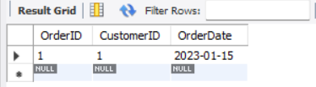

4. SQL-STORED PROCEDURED
Exercise 1: Create a Stored Procedure Goal: Create a stored procedure to retrieve employee details by department.
Steps: 1. Define the stored procedure with a parameter for DepartmentID.
2. Write the SQL query to select employee details based on the DepartmentID.
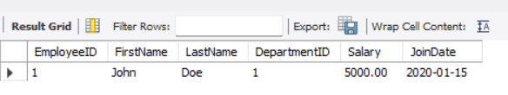
3. Create a stored procedure named `sp_InsertEmployee` with the following code:
CREATE PROCEDURE sp_InsertEmployee @FirstName VARCHAR(50), @LastName VARCHAR(50), @DepartmentID INT, @Salary DECIMAL(10,2), @JoinDate DATE AS BEGIN INSERT INTO Employees (FirstName, LastName, DepartmentID, Salary, JoinDate) VALUES (@FirstName, @LastName, @DepartmentID, @Salary, @JoinDate); END;

Exercise 4: Execute a Stored Procedure Goal: Execute the stored procedure to retrieve employee details for a specific department.
Steps: 1. Write the SQL command to execute the stored procedure with a DepartmentID
Parameter
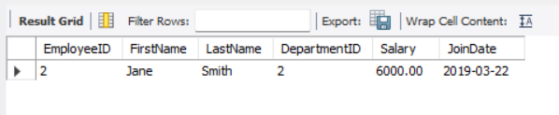
2. Execute the command and review the results. 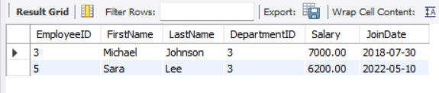

Exercise 5: Return Data from a Stored Procedure Goal: Create a stored procedure that returns the total number of employees in a department.
Steps: 1. Define the stored procedure with a parameter for DepartmentID.
2. Write the SQL query to count the number of employees in the specified department.

https://github.com/monu9523/Advanced-SQL/blob/main/4_StoredProcedured.sql

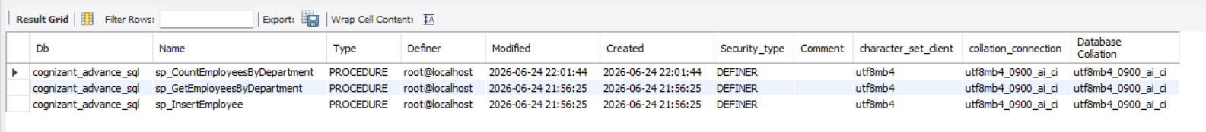
3. Save the stored procedure by executing the Stored procedure content.

5. SQL – FUNCTIONS
Exercise 7: Return Data from a Scalar Function Goal: Return the annual salary for a specific employee using `fn_CalculateAnnualSalary`.
Steps: 1. Execute the `fn_CalculateAnnualSalary` function for an employee with `EmployeeID = 1`.
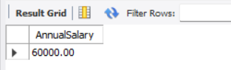
2. Verify the result. 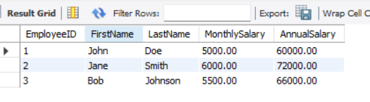

https://github.com/monu9523/Advanced-SQL/blob/main/5_Functions.sql

